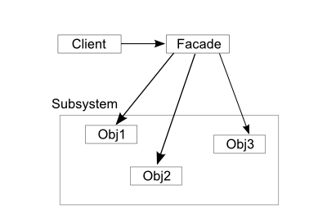

Facade pattern is different from adapter pattern because Facade  simplifies a class structure while adapter keeps the same class structure.

The Facade  pattern is a way to structure our API into subsystems to reduce ever growing size and complexity of interfaces of API.